ITM 311 Class Activity for Week 2 Exercise 2a

Name: Erick Cabrera Date: 09/06/2016

**Part 1 Sequential Control**

To demonstrate the concept of sequential control. Make sure that you place appropriate comments statements.

Problem: Write a JAVA program (class name should be Demograph) for asking demographic information. This program will

1. ask for the student’s name, the student’s city where they live and their state and country;
2. ask for how many courses the student is taking;
3. ask for how many credit hours the student is taking;
4. ask the student if they like JAVA (response is to be Y for yes or N for No).

The output should correctly reflect the input.

Place the code and a snapshot of the output below.

Source Code

/* Erick Cabrera

* September 9, 2016

* Java program that asks for demographic information

*/

import java.util.Scanner;

public class Demograph {

public static void main(String args[])

{

//declare a Scanner class object

Scanner sc = new Scanner(System.in);

//prompt user for their name

System.out.println("Please enter your name:");

//declare a local variable and read the string

String name = sc.nextLine();

//prompt user for location

System.out.println("Which city, state, and country do you currently reside in?");

//declare a local variable and read the string

String location = sc.nextLine();

//prompt user for number of courses they are taking

System.out.println("How many courses are you currently taking?");

//declare a local variable and read the integer

int courses = sc.nextInt();

//prompt user for number of credit hours they are taking

System.out.println("How many credit hours are you currently taking?");

//declare local variable and read the amount

double credits = sc.nextDouble();

//Ask user if they like Java or not

String YN;

while(true){

System.out.println("Do you enjoy JAVA? (Y for yes, N for no)");

//declare local variable and read the string

YN = sc.next();

//if YN = Y or N continue, else prompt user to answer again

if(YN.equalsIgnoreCase("Y") || YN.equalsIgnoreCase("N")){

System.out.println("Thank you for your time " + name + "!");

break;

}

else{

System.out.println("Please answer Y for yes or N for no");

}

}

//List user their answers

System.out.println("Here is what we got based off your answers:" + "\n");

System.out.print("Student Name: " + name + "\n" + "Location: " + location + "\n" +

"Courses: " + courses + "\n" + "Credit Hours: " + credits + "\n"

+ "Do you enjoy JAVA? " + YN);

sc.close();

}

}

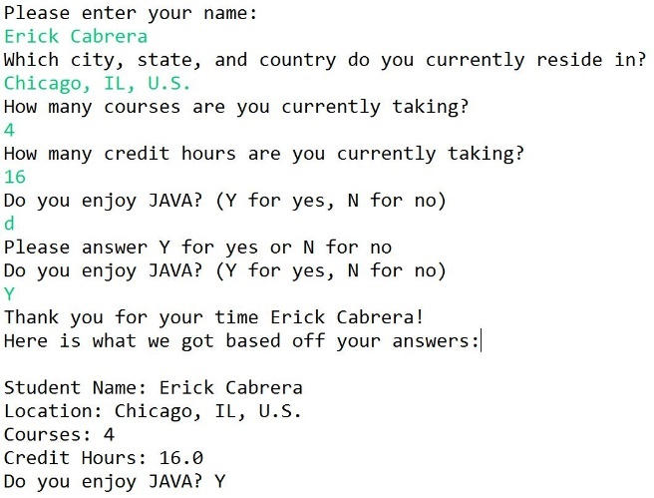 “Yes” Output “No” Output

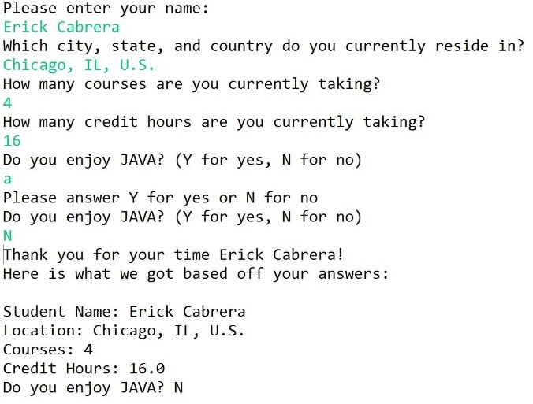

**Questions: Give examples to support your written answers.**

1. What is the difference between a float and a double datatype?
   1. Float (32 bit) has a much smaller range of numbers than double (64 bit) however saves you memory. Double is much more precise, that is why it is more commonly used.
      1. Float – 0.0f ; double – 0.0d
2. What is the difference between a char and String datatype?
   1. char is a single character while String is either one or a sequence of characters.
      1. e – char ; erick - String

**Part 2 Escape Character Use**

To demonstrate the use of escape characters when displaying character/alphanumeric data containing quotes, back slashes, etc. Examples of escape characters are:

\t - Insert a tab in the text at this point.  
\b - Insert a backspace in the text at this point.  
\n - Insert a newline in the text at this point.  
\r - Insert a carriage return in the text at this point.  
\f - Insert a formfeed in the text at this point.  
\' - Insert a single quote character in the text at this point.  
\" - Insert a double quote character in the text at this point.  
\\ - Insert a backslash character in the text at this point

Create a JAVA program that will print out all the following Strings:

**He said "Hello!" to me.**

**I said “Hello!” back.**

**The entire text exactly as written here:**

Hi-Diddle-Dee-Dee. An actor's life for me!  
A high silk hat, and a silver cane.  
A watch of gold, with a diamond chain.  
Hi-Diddle-Dee-Day an actor's life is gay!  
It's great to be a celebrity.  
An actor's life for me!  
  
Hi-Diddle-Dee-Dum. An actor’s life is fun!

Source Code

/* Erick Cabrera

* September 9, 2016

* Demo use of Escape Characters

*/

public class EscapeCharacters {

public static void main(String args[]){

System.out.println("He said " + "\"" + "Hello" + "\"" + " to me.");

System.out.println("I said " + "\"" + "Hello" + "\"" + " back." + "\n");

System.out.print("Hi-Diddle-Dee-Dee. An actor's life for me!" + "\n" +

"A high silk hat, and a silver cane." + "\n" +

"A watch of gold, with a diamond chain." + "\n" +

"Hi-Diddle-Dee-Day and actor's life is gay!" + "\n" +

"It's great to be a celebrity." + "\n" +

"An actor's life for me!" + "\n" + "\n" +

"Hi-Diddle-Dee-Dum. An actor's life is fun!");

}

}

Output

